Guadalupe Flores

November 13, 2019

IT FDN 100 A

Assignment 06

Intro to Programming (Python) Module 6

# Introduction

In the sixth segment of our class, was introduced to functions and their parameters. The lesson also includes the usage of variables and arguments and how to work with them. The assignment notes also included a section of debugging and understanding the distinction between local variables vs. global variables. The latter being variables declared in a “body of a script and may be used any place in the scripts.

# Webpages

In addition to reading the chapter, we were assigned to review tutorial web pages from the website listed below and uploading our documents onto GitHub to share with our fellow students. A selection of links are as followed:

Functions[: http://www.learnpython.org/en/Functions](http://www.learnpython.org/en/Functions)

Creating Functions: <https://www.youtube.com/watch?v=qO4ZN5uZSVg&feature=youtu.be>

GitHub: <https://github.com/>

# Applying our Knowledge

After reviewing the required reading, lecture notes, videos, and web pages, we then were required to complete an assignment similar to Module 5, by modifying a “ToDoFile” and adding additional functions to the script and using the debug feature in PyCharm. The final step was of the assignment was to upload our documents onto the GitHub website and create a weblink. See Figure 1

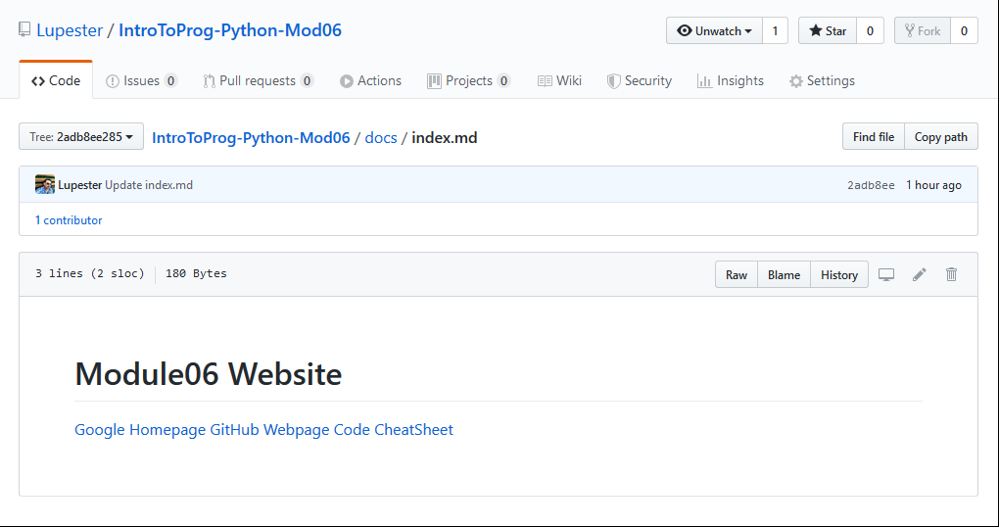

***Figure 1: GitHub Website***

# Creating the Program Script

The objective of the assignment was to rearrange some of the starter script provided for the assignment and create several functions (def) as shown below along with a snapshot of the script. See figure 2. The functions that I created are as followed:

def RemoveLine(strKeyToRemove):

def GetTaskDetails():

FileProcessor.RemoveLine(strKeyToRemove)

FileProcessor.AddRowToList(strTask, strPriority, lstTable)

blnItemRemoved, lstTable = FileProcessor.RemoveLine(strKeyToRemove)

FileProcessor.WriteListDataToFile(strFileName, lstTable)

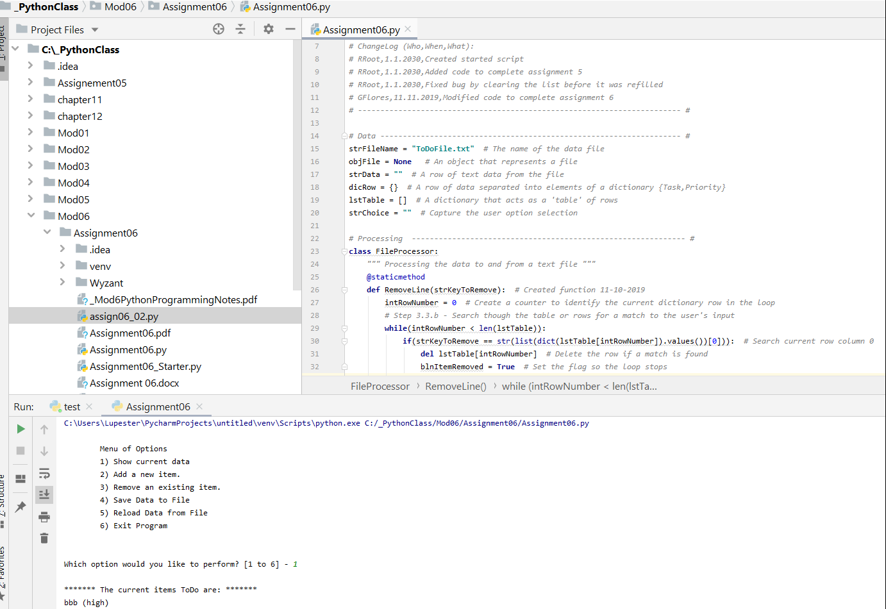

***Figure 2: Entering header information and codes in PyCharm for Module6***

# Running the Script

To test out your script in PyCharm select Run from the task menu. A lower console should open, with a Menu of Options. The user has six options. If the user selects “1) Show current data.” The program will show the current data and or “Add a new Item” or “Remove an existing item.” The program will continue to loop until the user’s selection of option ” Save Data to File” and or “Exit Program. See Figure 5 and 6. Also, our program included the function to create a text file and save it to Windows C: Drive. See figure 7.

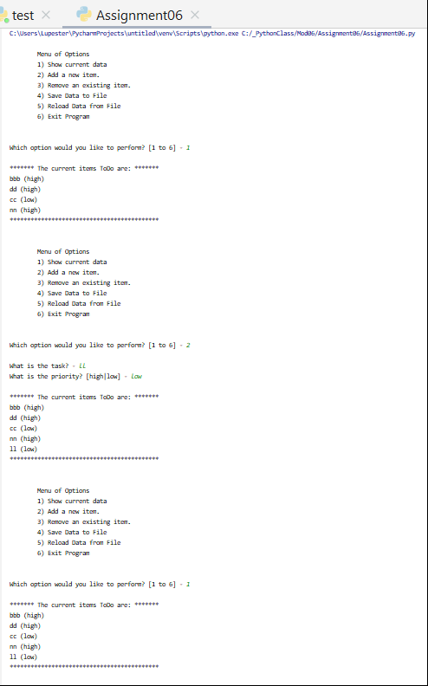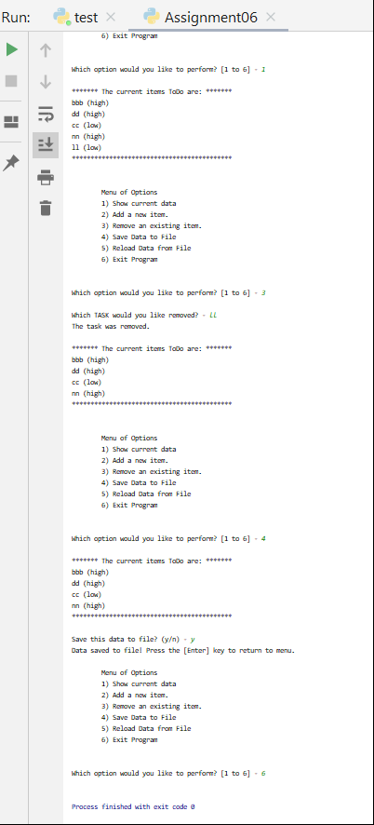

***Figure 5: PyCharm results of running the script shown in the bottom console***

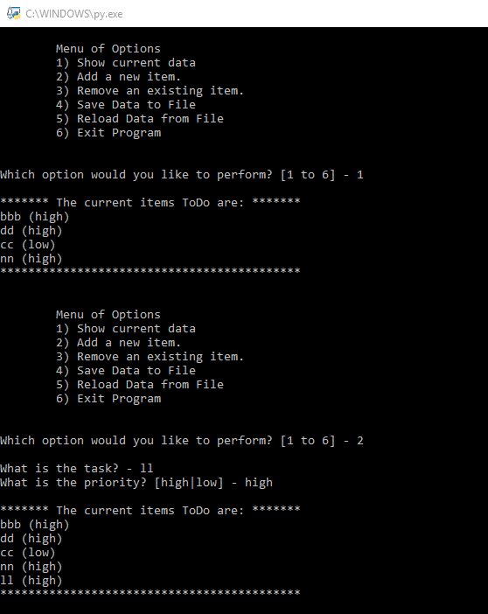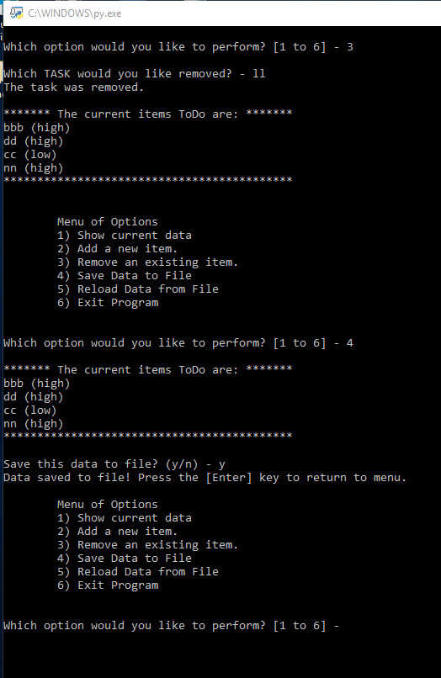

***Figure 6: Command Prompt To-do list Text file list.***

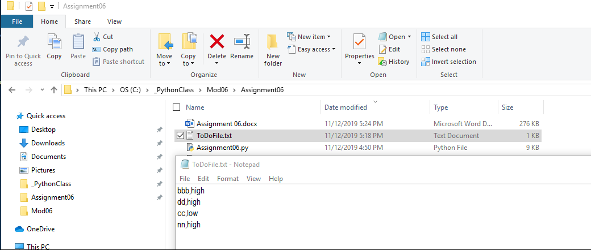

***Figure 7: To-do list Text file list saved.***

# Summary

In reading Chapter 6, and reviewing the lecture notes, webpages, practices running the lab assignment and reviewing the tutorials. Replicating the steps from assignment 5, I was able to create a subfolder, and a file, and essentially adding functions, and arguments to minimize repetition, displaying and storing the data results, that saves it, and creates a text file.